How to select membrane keyboard for Siemens Operator panel replace with good quality?

Let’s take 6AV3607-1JC20-0AX1 OP7/DP for example.

There are more and more membrane keyboard for Siemens 6AV3607-1JC20-0AX1 OP7/DP in the market, some quality good and other just so so, therefore, how to select a good quality membrane keyboard for siemens 6AV3607-1JC20-0AX1 OP7/DP is becoming more and more important.

Fist, the good quality membrane keyboard for siemens 6AV3607-1JC20-0AX1 OP7/DP must with correct dimensions, this is very important, if the dimensions wrong, will bring so much trouble during replacement.

Second, the good quality membrane keyboard for siemens 6AV3607-1JC20-0AX1 OP7/DP should be covered with 3M adhesive tape in the back which would make sure the keyboard connected with the plastic cover strong enough.

Third, the good quality membrane keyboard for siemens 6AV3607-1JC20-0AX1 OP7/DP must be tested 100% in good condition before shipment, make sure each button working well.

Last but no end, the good quality membrane keyboard for siemens 6AV3607-1JC20-0AX1 OP7/DP must provide at least 6 months warranty after sold, cause the end user have to wait some time to get the keyboard, if the seller only provide 30-60 days warranty, once faulty happened, the buyer would lost money.

Vicpas is the leading membrane keyboard suppliers, all of the membrane keyboard switch keypad are produced 1:1 with original, don't worry about dimensions, perfect replacement. meanwhile, all the membrane keyboard we provided are covered with 3M adhesive tape, very strong and tough when install, what's more, we test each membrane keyboard before shipment, make sure all of them are in excellent condition, finally, we provide up to 6 months (90 days) warranty for customers, if there has any problem, we will send the new one for replacement, save cost and time for customers.

Compatible with more part number:

6AV3607-1JC00-0AX0 OP7/PP
6AV3607-1JC00-0AX1 OP7/PP
6AV3607-1JC00-0AX2 OP7/PP
6AV3607-1JC20-0AX0 OP7/DP
6AV3607-1JC20-0AX1 OP7/DP
6AV3607-1JC20-0AX2 OP7/DP
6AV3607-1JC30-0AX0 OP7/DP12
6AV3607-1JC30-0AX1 OP7/DP12
6AV3607-1JC30-0AX2 OP7/DP12
6AV3607-5AA00-0AC0 OP7 PP
6AV3607-5BA00-0AK0 OP7 DP
6AV3607-5BB00-0AE0 OP7 DP
6AV3607-5BB00-0AF0 OP7 DP
6AV3607-5BB00-0AG0 OP7 DP
6AV3607-5BB00-0AH0 OP7 DP
6AV3607-5BB00-0AL0 OP7 DP
6AV3607-5CA00-0AD0 OP7 DP12
6AG1607-1JC20-4AX1 SIPLUS HMI OP7/DP
6AG1607-1JC30-4AX1 SIPLUS HMI OP7
6AG1607-1JC20-4AX2 SIPLUS HMI OP7/DP
6AG1607-1JC30-4AX2 SIPLUS HMI OP7
6AG1607-1JC20-4AX1 SIPLUS HMI OP7/DP
6AG1607-1JC30-4AX1 SIPLUS HMI OP7

Vicpas also provide membrane keyboard switch keypad for Siemen, Allen Bradley, B&R powerpanel, KUKA, Beijer, ABB. Beckhoff, ESA, LAUER, Engel, Fagor etc.

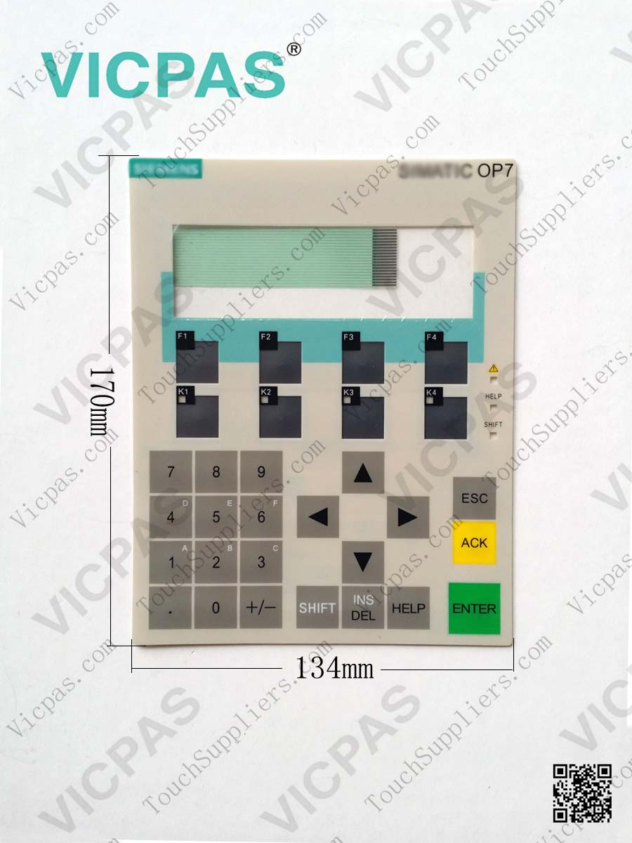
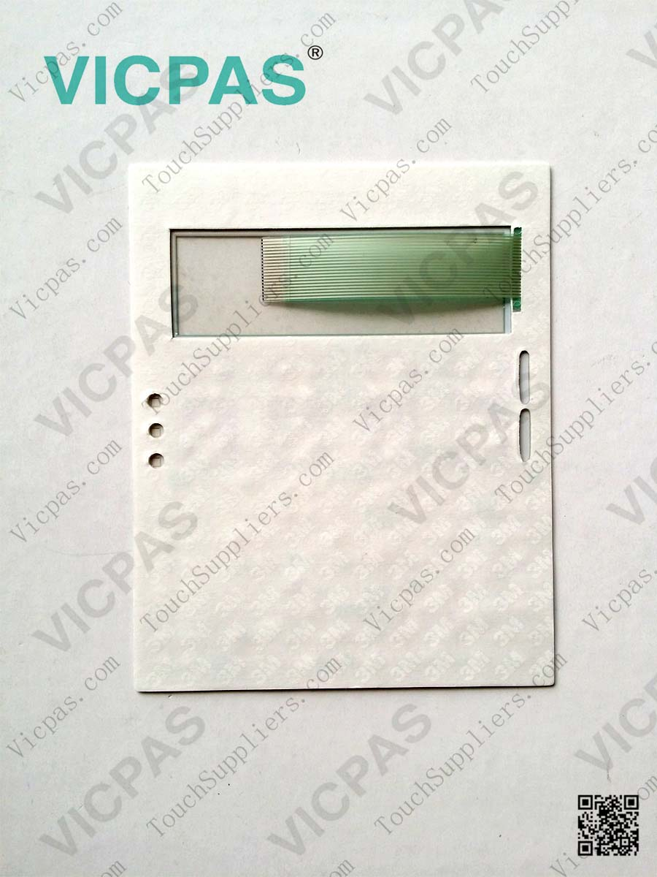

Our company name: Guangzhou Vicpas Touch Technology Co.,Ltd.
Our Brand: VICPAS
Our Slogan: Touch Vicpas, Touch the World!
Our email: kandy@vicpas.com Jack@vicpas.com
Our whatsapp / Wechat: +86-13763341328
Our Skype: cmt-kandy or jack90522
more details, please take a visit of our website:
Our Website: vicpas.com touchsuppliers.com cmtouchpanel.com

FAQ:

FAQ for Touch screen panel.

FAQ for Membrane keyboard keypad.

Vicpas’s Product:
For siemens touch screen replacement.
For allen bradley touch screen replacement.
For B&R powerpanel touch screen replacement.
For KUKA touch screen and keypad replacement
For siemens membrane keyboard replacement.
For allen bradley membrane keyboard replacement.
More detaisl, please Click “HERE”.

Vicpas mainly provide touch screen, touch panel, membrane keyboard switch keypad for Siemen, Allen Bradley, B&R, KUKA, Beijer, ABB. Proface, Omron, Schneider, Mitsubishi, Weintek, Advantech, Eaton, Red lion, VIPA, Panasonic, IDEC, Parker, Lenze, ESA, EZ automation, Fuji, Hakko, ELO, 3M touch, Microtouch, Gunze, DMC, AMT, Danielson, Fujistu, Liyitech, Higgstec, Abontouch, Gtouch, KDTouch, EELY, Hantouch, Inotouch, Versatouch, Beckhoff, ESA, LAUER, Engel, Fagor, UniOp etc. OEM is available for us. All of them are in stock, could be shipped out immediately via DHL, FEDEX, UPS, TNT, EMS, TOLL, DPEX etc.

Warranty: All the touch screen and membrane keyboard are brand new and we provide up to 12months warranty.

Vicpas is focus on Wholesale, warmly welcome Automation repair Company, Electric Repair Company, Board Repair Company, Local Trading Company, Ebay Big Seller, Amazon Big Seller etc from all overlay world to discuss and work together, If meet urgent shipment, we would ship the parcel to your customers directly, shipper name basic on your request, make sure you and your customers safe and keep on ordering product from your company.

Follow VICPAS on Facebook, Linkedin, Google Plus, Blog, YouTube, Twitter, Instagram, Pinterest get more promotion details.

